**NSSA221 Systems Administration I**

**Lab 02 Report**

# Name: Marveh Mustafa - Rania Kanaan - Suhaila Alfalasi - Saeed Falaknaz - Alia AlYammahi Grade ____/100

Use this template to answer questions related to Lab 2. Submit this template to the Lab Report 02 (LR02) drop box by the due date. Late submissions are subject to a 20% penalty. You must use this template and submit the document in Microsoft Word or Adobe PDF any other format will result in a zero grade for the report. When submitting your document, please save it in the following format, use LR02, followed by an underscore, followed by the first initial of your first name in uppercase, and your entire last name with the first letter in uppercase.

Example: LR02_GArcoraci.doc.

**Question 1 (20 points)**

Describe the general purpose of a domain controller. How does Active Directory establish administrative boundaries using object containers? What Active Directory objects are used to create security boundaries? What is the purpose of Relative and Security IDs?

The domain controller is in charge of the authorization of users. The domain controller confirms whether the user has permission to access domain resources. Active Directory is a database that makes use of object containers such as organizational units and domains. To define administrative boundaries, the active directory employs organizational units. First, the objects are organized in a structure known as a hierarchy by the Active Directory. There are built-in containers in this framework that are domains, and these domains control administrative responsibilities. The organizational units inside domains aid in the further organization of items in the active directory (Blackwell, 2022). To build security boundaries, Active Directory uses a forest, which has numerous domains that share a similar schema (Chai & Gillis, 2021). Security IDs are important for maintaining security databases in an active directory since they are used to identify users and regulate access. Relative IDs are unique numbers that are part of security IDs; they assist in maintaining the security IDs' uniqueness (Morgan, 2020).

**Question 2 (20 points)**

Explain the importance of integrating DNS with Active Directory. Most notably, how the clients and servers use it. What is the significance of the SRV resource record in DNS, and how does it relate to the services in a domain?

Integrating DNS with Active Directory assists clients in locating and accessing domain controllers, which are responsible for user authentication (*DNS and AD DS*, 2021). Service resource records (SRV) help provide users with more information about a certain domain; they are used to discover and access domain controllers and specific services inside a domain that the user is requesting (Johnson, 2023).

**Question 3 (20 points)**

Active Directory uses groups to elevate user privileges; three of the more critical groups are Enterprise Admins, Schema Admins, and Domain Admins. Describe the primary function of each of these groups and why you need to be selective about adding users to them.

Enterprise Admins: This is a group that has access to the domains in the Active Directory forest. Domains in the forest are created by enterprise administrators. However, we must be cautious while adding them because they might occasionally alter the forest (Schneider, 2023).

Schema Admins: It is a group that is used to alter the schema of the active directory and to organize the active directory. Nevertheless, we must exercise caution while utilizing the schema administrators since modifications to the Active Directory schema might affect the entire forest (Schneider, 2023).

Domain Admins: It is used to establish and modify group policies and GPOs, as well as manage user accounts. However, domain administrators should be monitored and observed occasionally because adding users might pose security difficulties (Campbell, 2023).

**Question 4 (20 points)**

What are the SamAccountName and the User Principal Name, as they relate to Active Directory?

The SamAccountName is the User Logon name, utilized for security purposes in Active Directory; no two SamAccountNames can exist in Active Directory. Because it is easier to remember, the UserPrincipalName is more commonly used in Active Directory. The User Principal Name (UPN) is a newer User Logon Name identifier that, like the SamAccountName, cannot be replicated (Morgan, 2021).

**Question 5 (20 points)**

What does it mean to “link,” a group policy object? What is the order of precedence regarding GPOs, and explain how GPOs are inherited and enforced relative to the order of precedence? What process would you use to unlink a policy?

To "link" a group policy object, connect it to an active directory container, a domain, or an organizational unit. GPOs are inherited and enforced in descending order of precedence. Local group policy has the least precedence because it is applied at the computer level, followed by GPO connected to the site, which applies to all objects in the site; GPO linked to the domain, which applies to all objects in the domain; and finally, GPO linked to Organizational Unit OU, which has the most precedence because it applies to all objects in the organizational unit. If you want to enforce a GPO linked to a site, for example, you must first right-click on the site and then click on show sites, then click OK to check the sites in GPMC, and once expanded, click on the site that you want to enforce (Smith, 2019). To unlink a GPO policy, first, go to the management tab and click on manage GPO links, then choose the GPO policy you want to unlink, click on manage, and then click on remove links from the options (*Add/Remove GPO Links*, 2023).



To maintain fairness, please make sure to include all required screenshots in the report. Neglecting to include a screenshot will result in a 5% deduction from the report grade. If three or more screenshots are missing, the report will receive a grade of zero. This policy applies not only to this lab but also to any future labs. It is crucial that the screenshots accurately present the required information and are easily legible, clear, and readable. Modifying the information in the screenshots is considered academic dishonesty, resulting in a grade of zero for the report and potentially impacting the overall course grade.

All screenshots must be labeled in the report, using the following titles.

Figure 1 – Active Directory and DHCP Scope Verification

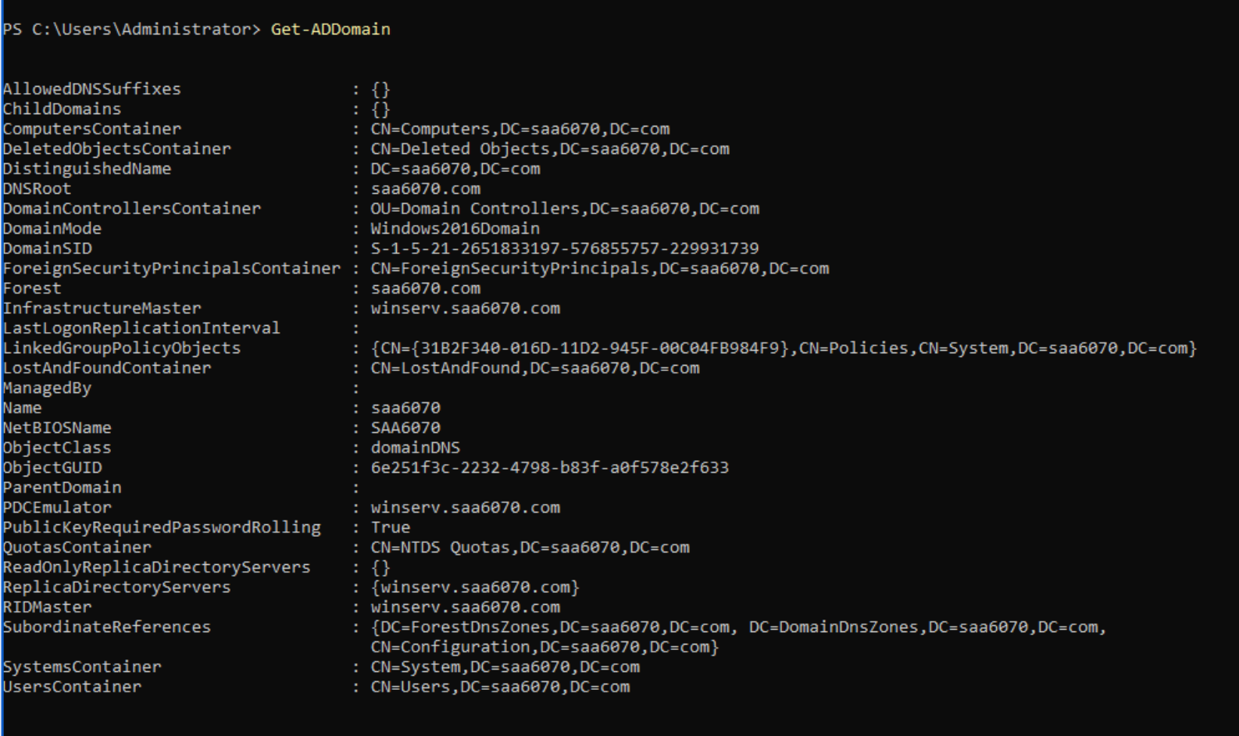

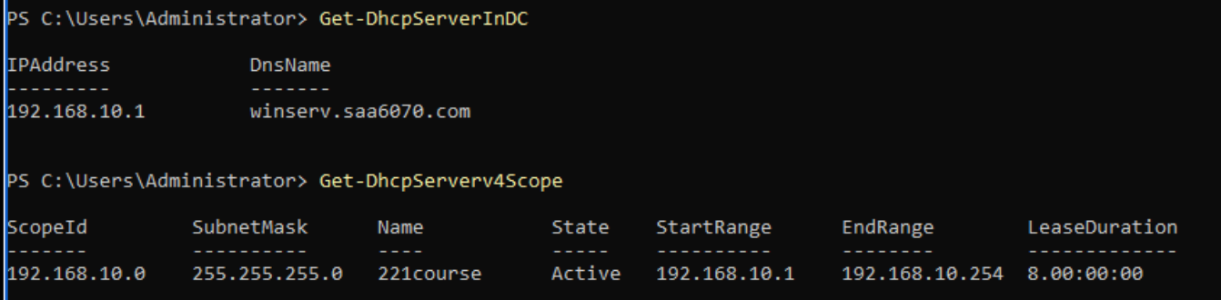

Figure 2 – Windows 10 Network Configuration Information

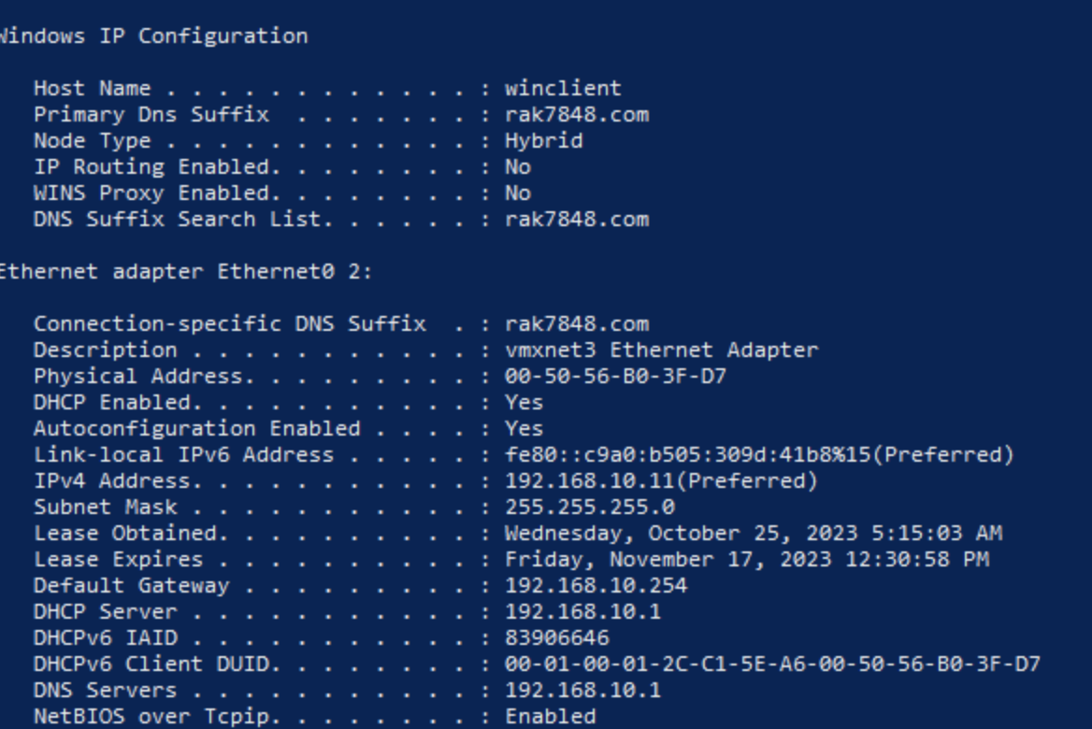

Figure 3 – Windows 10 Domain Verification

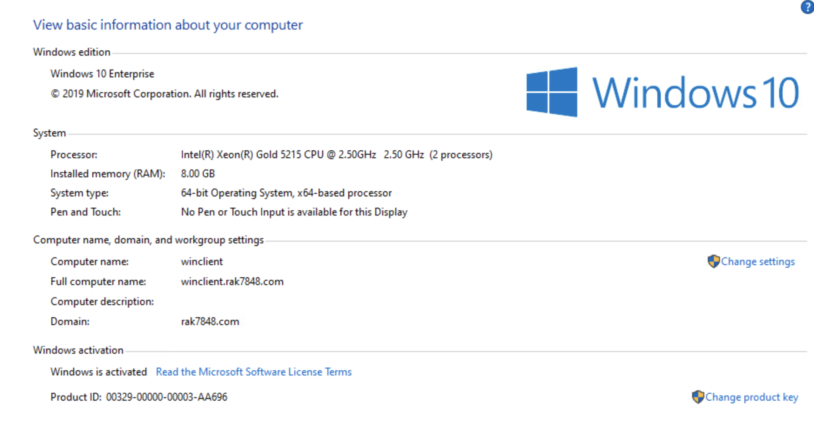

Figure 4 – Windows 10 Network and Domain Verification

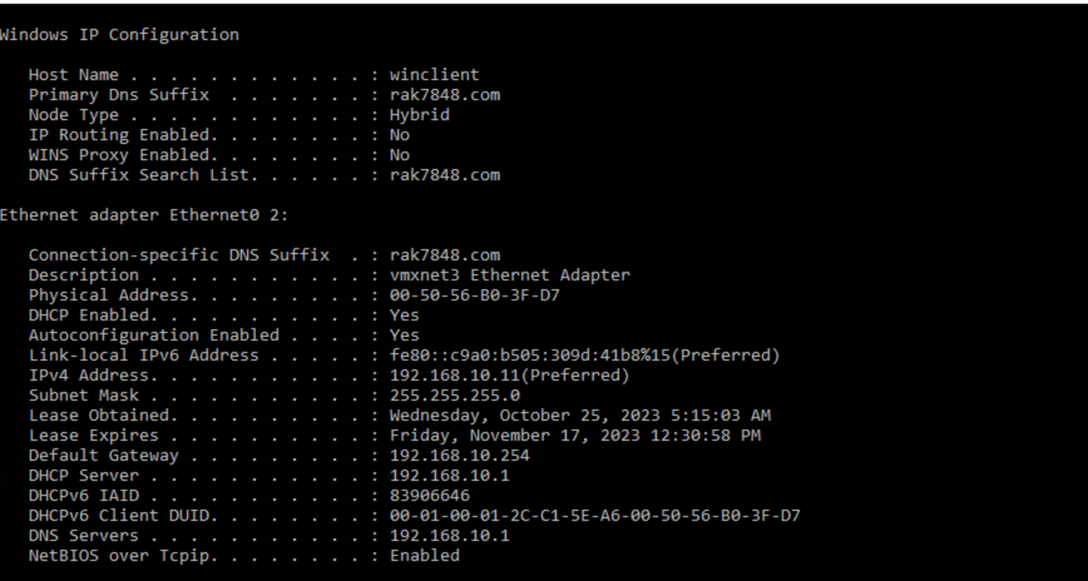



Figure 5 – Rocky Linux Verification

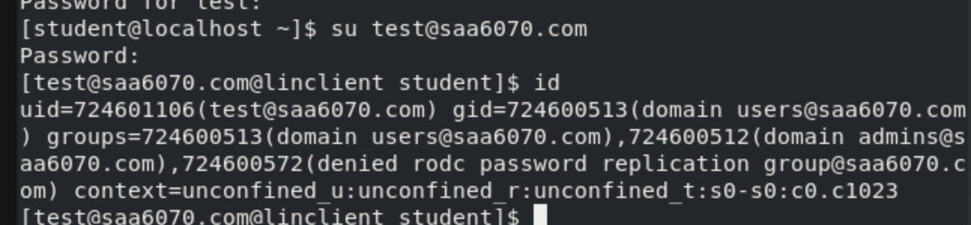

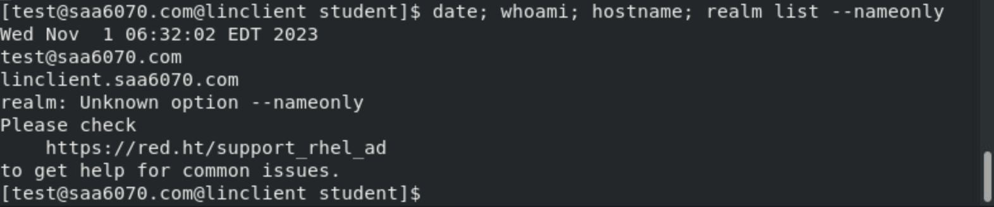Figure 6 – PowerShell **Get-ADDomain** Output

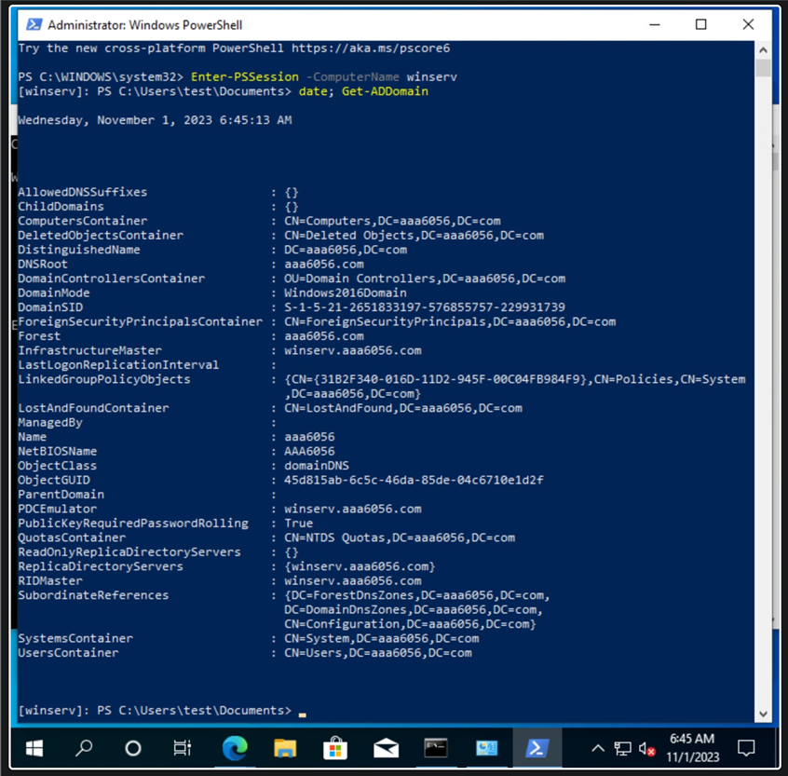

Figure 7 – First Organizational Unit

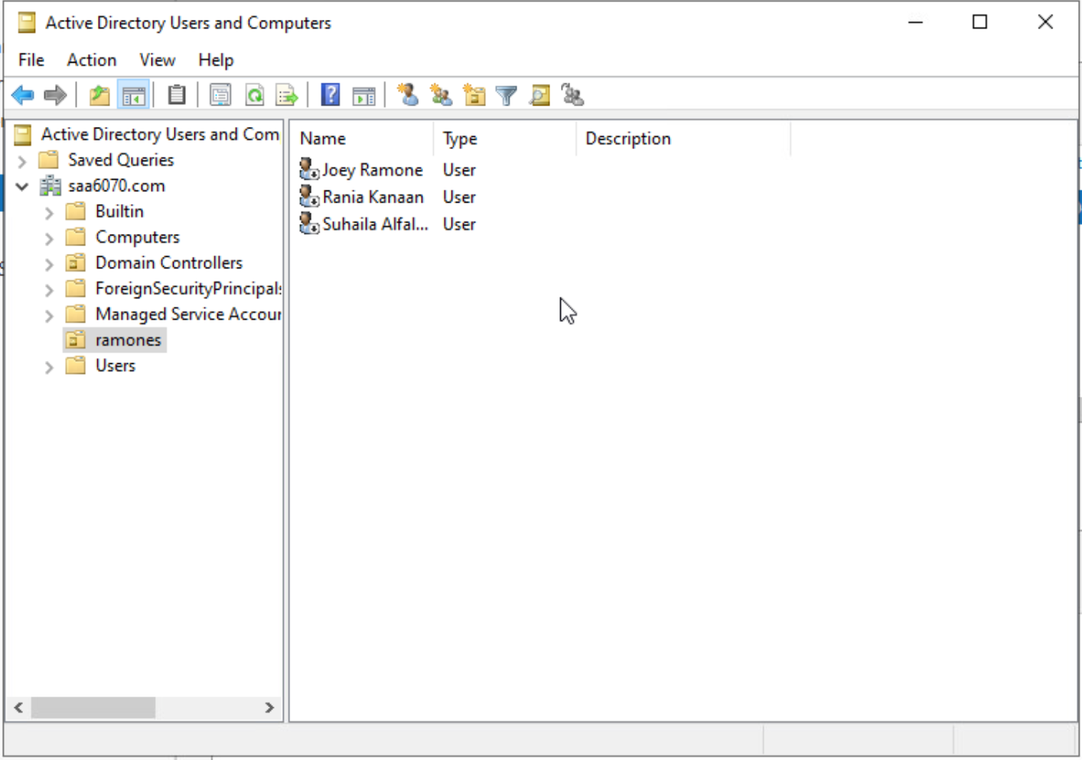

Figure 8 – Second Organizational Unit

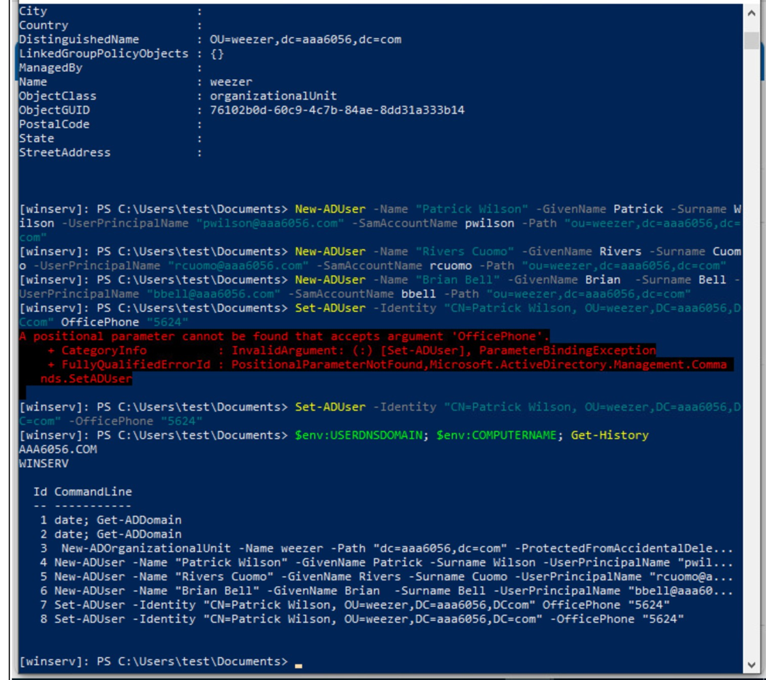

Figure 9 – PowerShell History

Figure 10 – GPO Reports

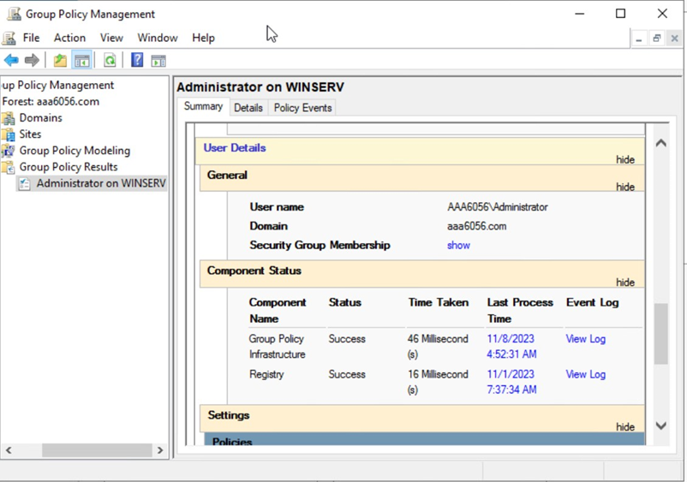

what

*If you need multiple screenshots for the GPO reports just append a letter, for example, Figure 10a, Figure 10b.

**References:**

Blackwell, J. (2022, November 29). *Default Containers and OUs in Active Directory upon Installation.* Imanami. <https://www.imanami.com/what-is-the-only-ou-created-by-default-after-installing-active-directory/#:~:text=Other%20Built-in%20Containers%20in%20Active%20Directory&text=Built-in%20container%2C%20It%20manages,newly%20formed%20domain%20computer%20accounts>

Chai, W., & Gillis, A. S. (2021, June 7). *Active directory.* SearchWindowsServer. [https://www.techtarget.com/searchwindowsserver/definition/Active-Directory#:~:text=According%20to%20 Microsoft%2C%20the%20 forest,a%20domain%20must%20be%20 unique](https://www.techtarget.com/searchwindowsserver/definition/Active-Directory#:~:text=According%20to%20Microsoft%2C%20the%20forest,a%20domain%20must%20be%20unique)

Morgan. (2020, March 16). *Difference between a RID and a SID in Active Directory.* MorganTechSpace. <https://morgantechspace.com/2013/10/difference-between-rid-and-sid-in.html>

I. (2021, July 29). *DNS and AD DS.* Microsoft Learn. <https://learn.microsoft.com/en-us/windows-server/identity/ad-ds/plan/dns-and-ad-ds>

Johnson, D. *What Is SRV Record in DNS & How Does It Benefit Your Website.* (2023, May 25). HostAdvice. <https://hostadvice.com/blog/domains/what-is-srv-record-in-dns/>

Schneider, A. (2023, October 5). AD Roles: *Enterprise Admins and Schema Admins. Ravenswood Technology Group.* <https://www.ravenswoodtechnology.com/ad-roles-enterprise-admins-and-schema-admins/>

Campbell, D. (2023, October 30). *Domain Administrators vs Local Administrators.* TRINUS. [https://www.trinustech.com/blog/theres-admin-and-theres-admin-domain-administrators-vs-local-administrators/#:~:text=So%2C%20 consider%20a%20Domain%20Administrator,to%20that%20 Active%20Directory%20 organization](https://www.trinustech.com/blog/theres-admin-and-theres-admin-domain-administrators-vs-local-administrators/#:~:text=So%2C%20consider%20a%20Domain%20Administrator,to%20that%20Active%20Directory%20organization)

Morgan. (2021, November 15). *samAccountName vs userPrincipalName*. MorganTechSpace. <https://morgantechspace.com/2014/04/samaccountname-vs-userprincipalname.html>

Smith, R. *Getting Group Policy Object Precedence Right.* (2019, July 2). <https://blog.netwrix.com/2019/07/02/getting-group-policy-object-precedence-right/>

*Add/remove GPO links.* (2023). <https://www.manageengine.com/products/ad-manager/help/gpo-management/add-remove-link.html>